**Installation Instructions of RabbitMQ Server**

RabbitMQ is an open-source message broker software that implements the Message Queuing Telemetry Transport (MQTT), Advanced Message Queuing Protocol (AMQP) and Streaming Text Oriented Messaging Protocol, other protocols via a Plugins.

**Message Queuing Telemetry Transport (MQTT)** : A messaging broker's responsibility is to receive messages from publishers (applications that post them) and deliver them to users (applications that process them).

**Advance Message queuing protocol (AMQP):** Communication between conforming client applications and conforming messaging middleware brkers is made possible by the messaging protocol AMQP.

**Official Document:** [RabbitMQ](https://www.rabbitmq.com/install-debian.html)

**Steps of RabbitMQ Server Installation on Ubuntu server**

**Table of Content**

1. **Updating the system**
2. **Installing Erlang**
3. **Add RabbitMQ Repository to Ubuntu**
4. **Install RabbitMQ Server Ubuntu**
5. **Enable the RabbitMQ Management Dashboard (Optional)**
6. **Set RabbitMQ Cluster (Optional)**
7. **Step 1: Updating the system:** In the first step check before proceeding, ensure that the server packages are up to date. Use this command to achieve that:

**sudo apt update sudo apt upgrade -y**

**sudo apt upgrade -y**

1. **Step 2: Installing Erlang :** RabbitMQ requires Erlang to be installed first before it can run. Install Erlang on Ubuntu system using This command.

**sudo apt install -y erlang**

1. **Step 3: Add RabbitMQ Repository to Ubuntu:** Team RabbitMQ maintains an [**apt repository on Package Cloud**](https://packagecloud.io/rabbitmq/rabbitmq-server), a package hosting service. It provides packages for most recent RabbitMQ releases.

**curl -s https://packagecloud.io/install/repositories/rabbitmq/rabbitmq-server/script.deb.sh | sudo bash**

1. **Step 4: Install RabbitMQ Server Ubuntu:** RabbitMQ can be found in the default Ubuntu repos. Install using this command:

**sudo apt update**

**sudo apt install rabbitmq-server**

Hit the **y**key to start the installation.

After installation, RabbitMQ service is started and enabled to start on boot. To check the status, run:

**systemctl status rabbitmq-server.service**

You can confirm if the service is configured to start on boot using the command:

**systemctl is-enabled rabbitmq-server.service**

If it returns disabled, enable it by running:

**sudo systemctl enable rabbitmq-server**

1. **Step 5: Enable the RabbitMQ Management Dashboard (Optional):**The RabbitMQ Management Web dashboard is an optional feature for simple management.

**sudo rabbitmq-plugins enable rabbitmq\_management**

The Web service should be listening on TCP port**15672**

If you have an active UFW firewall, open both ports 5672 and 15672:

**sudo ufw allow proto tcp from any to any port 5672,15672**

Access it by opening the URL **http://[server IP|Hostname]:15672**

Example : **http://localhost:15672**

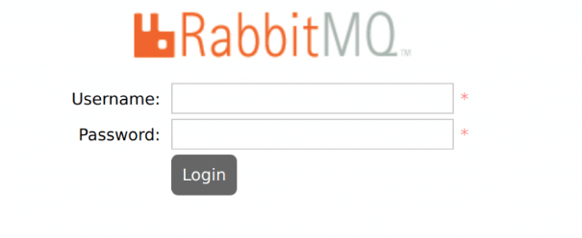

By default, the **guest** user exists and can connect only from **localhost**. You can login with this user locally with the password “**guest”**

To be able to login on the network, create an admin user like below:

**sudo rabbitmqctl add\_user admin StrongPassword**

**sudo rabbitmqctl set\_user\_tags admin administrator**

Login with this admin username and the password assigned

1. **Step 6: Set RabbitMQ Cluster (Optional)**

If you need to achieve high availability and higher throughput, consider configuring RabbitMQ cluster on your Ubuntu servers by following the guide below:

**[How to Configure RabbitMQ Cluster on Ubuntu](https://computingforgeeks.com/how-to-configure-rabbitmq-cluster-on-ubuntu/" \t "_blank)**